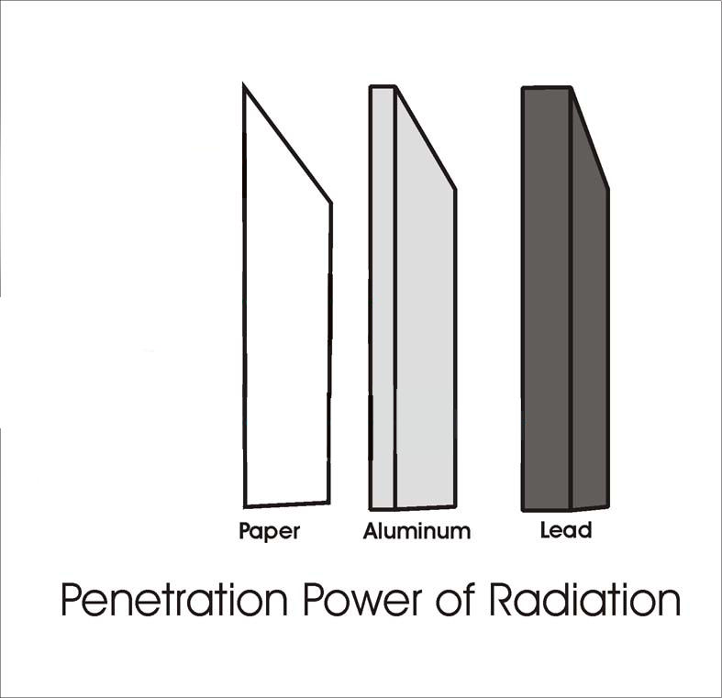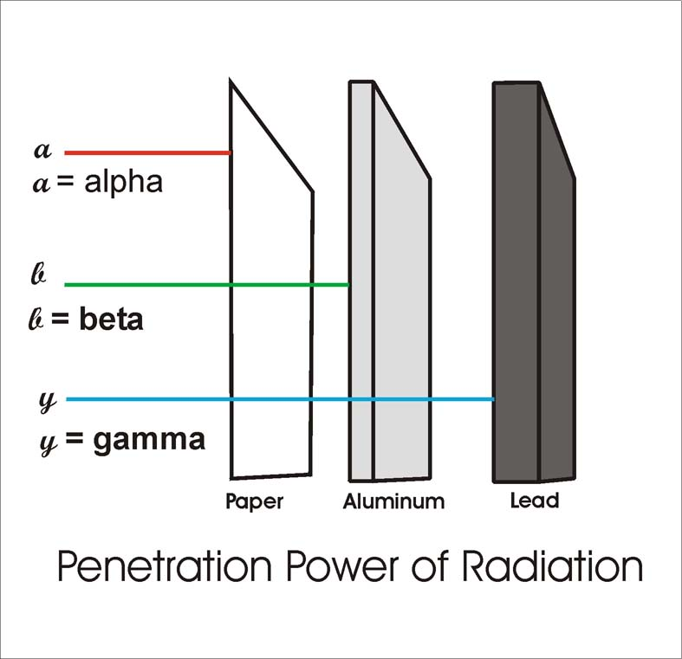

**Properties of Ionising Radiation**

1. Draw the structure of each of the three types of ionising radiation in the boxes.

2. Complete the symbols to show the atomic and mass numbers.

3. Show the penetrating power of each type of radiation on the diagram.

4. List the three types of ionising radiation in order of increasing ionising power.

5. Complete the table to summarise the information.

**γ**

**β**

**α**

**Type**

**Mass**

**Charge**

**Ionising Power**

**Penetrating Power**

**Uses**

Most Ionising

Least Ionising

α

γ

β

**Gamma**

**Beta**

**Alpha**

**Gamma**

**Beta**

**Alpha**